Objectives:

* JavaFX or JFrame

There are two projects, each worth 50%

**Project #1** (using Java FX or JFrame complete the following below)

**#1 print screen the running application with code below here**

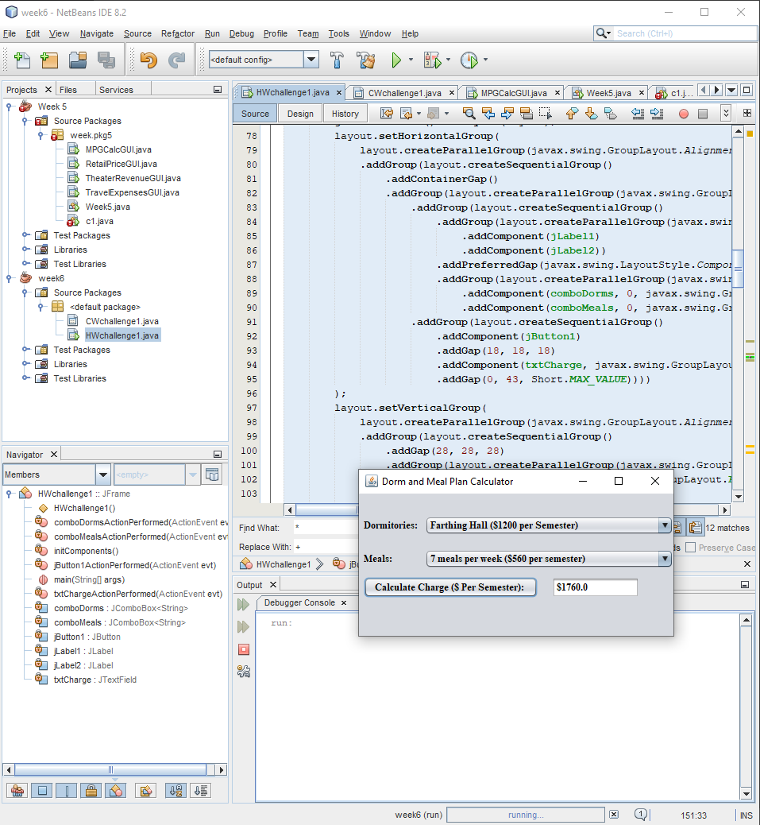

private void jButton1ActionPerformed(java.awt.event.ActionEvent evt) {

// TODO add your handling code here:

double allen = 1500;

double pike = 1600;

double farthing = 1200;

double suites = 1800;

double meal7 = 560;

double meal14 = 1095;

double mealU = 1500;

double a7 = allen + meal7;

double p7 = pike + meal7;

double f7 = farthing + meal7;

double s7 = suites + meal7;

double a14 = allen + meal14;

double p14 = pike + meal14;

double f14 = farthing + meal14;

double s14 = suites + meal14;

double aU = allen + mealU;

double pU = pike + mealU;

double fU = farthing + mealU;

double sU = suites + mealU;

if (comboDorms.getSelectedIndex()== 0 && comboMeals.getSelectedIndex() == 0)

{

txtCharge.setText("$" + a7);

}

else if (comboDorms.getSelectedIndex()== 1 && comboMeals.getSelectedIndex() == 0)

{

txtCharge.setText("$" + p7);

}

else if (comboDorms.getSelectedIndex()== 2 && comboMeals.getSelectedIndex() == 0)

{

txtCharge.setText("$" + f7);

}

else if (comboDorms.getSelectedIndex()== 3 && comboMeals.getSelectedIndex() == 0)

{

txtCharge.setText("$" + s7);

}

else if (comboDorms.getSelectedIndex()== 0 && comboMeals.getSelectedIndex() == 1)

{

txtCharge.setText("$" + a14);

}

else if (comboDorms.getSelectedIndex()== 1 && comboMeals.getSelectedIndex() == 1)

{

txtCharge.setText("$" + p14);

}

else if (comboDorms.getSelectedIndex()== 2 && comboMeals.getSelectedIndex() == 1)

{

txtCharge.setText("$" + f14);

}

else if (comboDorms.getSelectedIndex()== 3 && comboMeals.getSelectedIndex() == 1)

{

txtCharge.setText("$" + s14);

}

else if (comboDorms.getSelectedIndex()== 0 && comboMeals.getSelectedIndex() == 2)

{

txtCharge.setText("$" + aU);

}

else if (comboDorms.getSelectedIndex()== 1 && comboMeals.getSelectedIndex() == 2)

{

txtCharge.setText("$" + pU);

}

else if (comboDorms.getSelectedIndex()== 2 && comboMeals.getSelectedIndex() == 2)

{

txtCharge.setText("$" + fU);

}

else if (comboDorms.getSelectedIndex()== 3 && comboMeals.getSelectedIndex() == 2)

{

txtCharge.setText("$" + sU);

}

}

**Project #2** (using Java FX or JFrame complete the following below)

**#2 print screen the running application with code below here**

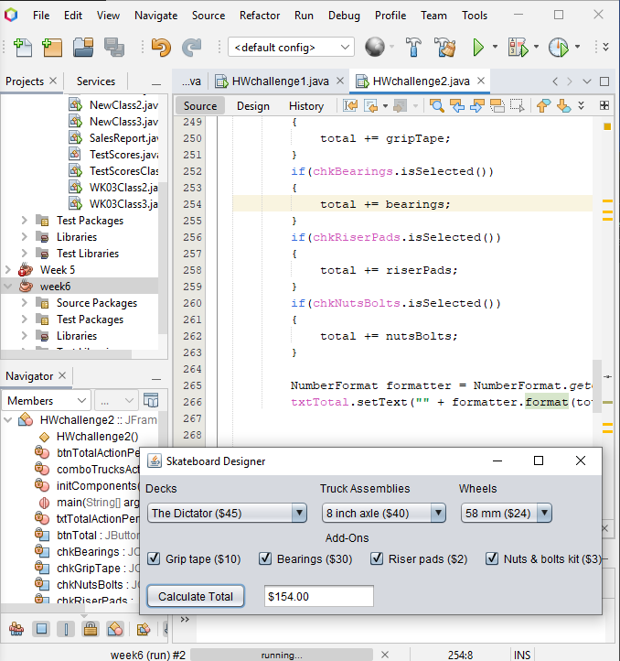

private void btnTotalActionPerformed(java.awt.event.ActionEvent evt) {

// TODO add your handling code here:

//Initialize variables

double masterThrasher = 60;

double dictator = 45;

double streetKing = 50;

double axle775 = 35;

double axle8 = 40;

double axle85 = 45;

double mm51 = 20;

double mm55 = 22;

double mm58 = 24;

double mm61 = 28;

double gripTape = 10;

double bearings = 30;

double riserPads = 2;

double nutsBolts = 3;

double total = 0;

//Calculates total

switch (comboDecks.getSelectedIndex()) {

case 0:

total += masterThrasher;

break;

case 1:

total += dictator;

break;

case 2:

total += streetKing;

break;

default:

JOptionPane.showMessageDialog(null, "Invalid input. Please try again.");

System.exit(1);

}

switch (comboTrucks.getSelectedIndex()) {

case 0:

total += axle775;

break;

case 1:

total += axle8;

break;

case 2:

total += axle85;

break;

default:

JOptionPane.showMessageDialog(null, "Invalid input. Please try again.");

System.exit(1);

}

switch (comboWheels.getSelectedIndex()) {

case 0:

total += mm51;

break;

case 1:

total += mm55;

break;

case 2:

total += mm58;

break;

case 3:

total += mm61;

break;

default:

JOptionPane.showMessageDialog(null, "Invalid input. Please try again.");

System.exit(1);

}

if(chkGripTape.isSelected())

{

total += gripTape;

}

if(chkBearings.isSelected())

{

total += bearings;

}

if(chkRiserPads.isSelected())

{

total += riserPads;

}

if(chkNutsBolts.isSelected())

{

total += nutsBolts;

}

NumberFormat formatter = NumberFormat.getCurrencyInstance();

txtTotal.setText("" + formatter.format(total));

}

**Submit this document to Module 6 Homework**